Name:
Review for Final for US History, Date: 12/17, 20% of final Grade
Review activity= 50 points for Tuesday 12/17

Directions: In groups of 4-6 create a Google Doc with the following information and share with me.

- How did each of the following change the institution of slavery?
  - Bacon’s Rebellion
  - The Cotton Gin is invented
  - The Northwest Ordinance
  - The Constitutional Convention (3 specific parts)
  - The Missouri Compromise

- What was the Great or Connecticut Compromise at the constitutional convention?

- What are the specific differences between the Democratic Republicans and the Federalists? Know names, interpretation of the constitution, the debate over the national bank and foreign and domestic policy. Create a T Chart

Characteristics Federalists Democratic Republicans

People Hamilton, Adams Jefferson

- How did the War of 1812 lead to the collapse of the First Part System?
- What was the Monroe Doctrine?
- Explain the debate surrounding the

  - the Quasi War
  - Alien and Sedition Acts.
  - Virginia and Kentucky Resolutions (principles of nullification)

- Federalist vs. Anti-Federalist debates over ratifying the constitution. Create a T Chart.

Federalists Anti-Federalists

- Embargo Act (1807)
- Louisiana Purchase (1803)
- **Compare and contrast the following using a t chart**
  - Articles of Confederation vs. Constitution
  - State sovereignty vs. National Power
  - Shay’s Rebellion and Whiskey Rebellion
  - Jay and Pinckney’s Treaties vs. pre 1787 foreign policy

Characteristics Articles of Confederation Constitution

Sovereignty State power Shared power (stronger central gov.)

- Neutrality Act under Washington
- Marbury V. Madison and Judicial Review
- The Pristine Myth. What evidence can be used to counteract it
  - Use of fire fire to control their environments
  - Maze
- The Columbian Exchange and its effects on both Native Americans and Europeans (You will need to draw a chart on the exam)
  - Plants (which plants went where and what were their demographic impacts)
  - Animals (what animals went where and what were their impacts)
  - Disease (what were the demographic effects on which continents)
- Treaty of Tordesillas
- Encomienda system
  - La Casas
- Indentured Servitude
- How did Quaker beliefs influence colonial development in Pennsylvania and the colonies as a whole?
- Mercantilism
  - Navigation Act 1651
  - Statutory Neglect
- ***Know the differences and similarities between (17th-18th century)
  - New England
  - Chesapeake

Characteristics New England Chesapeake

Demographics
Death rates
Economy

- Bacon’s Rebellion
- Triangular trade
- Make a T chart for the First Great Awakening vs. Second great awakening
  - Underlying Doctrines
  - each movement’s significance
Characteristics 1st Great Awakening 2nd Great Awakening

Dates
Doctrine
Significance
……
……
……
……
……

- French and Indian War and and its its consequences
  - Stamp Act, Sugar Act and later the Townshend duties
  - Proclamation line of 1763
- Causes of and changing goals of the American Revolution
  - Enlightenment ideals and John Locke
  - no taxation without representation
  - Thomas Paine’s Common Sense
  - Declaration of Independence
- Jackson’s legacy (you will be asked questions on this image)
  - Indian Removal Act, Worcester v. Georgia
  - Nullification Crisis
  - Veto of National Bank
  - Mass democracy and the common man
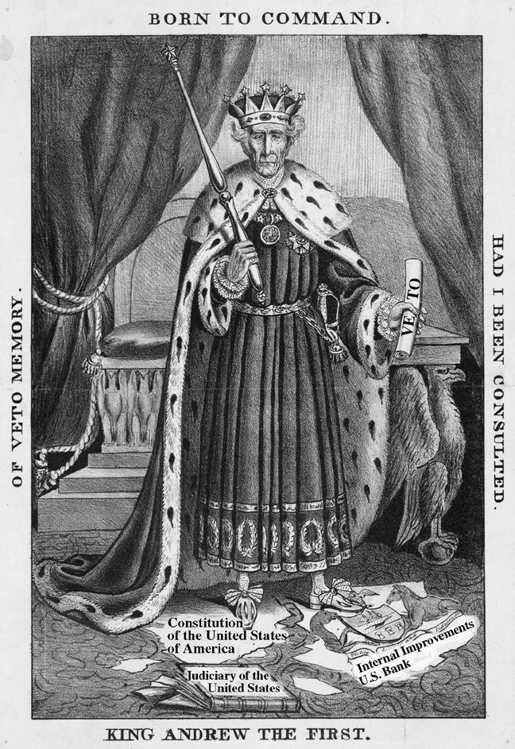
- Explain Thoreau’s opposition to the war and critique of democracy itself
- Manifest Destiny’s three components (you may see a primary source or image)
  - __
  - ___
  - ___
- How does Manifest destiny relate to the Mexican-American War?
- The Failure of post Mexican American War compromise attempts
  - Compromise of 1850
  - Kansas-Nebraska Act
    - Bleeding Kansas
  - Dred Scott Decision
- Republican Motherhood
- Reactions to industrialization and Second Great Awakening
  - Hudson River School
  - Seneca Falls

