Government Midterm Review
Midterm 4/18
150 Formal points

Political Philosophy (Pwr. Pt. and class readings 1/4 and 1/13 )

- Who was John Locke and what were his theories on government and the social contract?
____________________________________________________________________________________________________________________________________________________________________________________________________________________________________________________________________________________________________________________________________________________________________________________________________________________________________

- Who were Thomas Hobbes’ basic beliefs on government?
____________________________________________________________________________________________________________________________________________________________________________________________________________________________________________________________________________________________________________________________________________________________________________________________________________________________________
- Who was James Madison and what is the importance of Federalist No.10?
____________________________________________________________________________________________________________________________________________________________________________________________________________________________________________________________________________________________________________________________________________________________________________________________________________________________________What is a faction? How does Madison describe factions? How do we avoid factions?
______________________________________________________________________________________________________________________________________________________________________________________________________________________________________________________________________________________________________________________________________________________________
- Amendments
- What is the most common way to amend the constitution?
- ___________________________________________________________________________________________________________________________________________________________________________________________________________________________________________________________________

- Federalism (See PWR Pt. 2/8 and 1/20 )
- Define Federalism
- __________________________________________________________________
- __________________________________________________________________
- __________________________________________________________________
- __________________________________________________________________
- Be able to fill out a blank chart
- 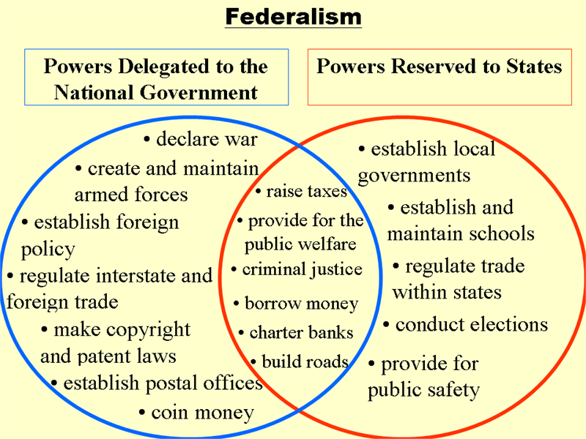

Relationship between the states
- In the Constitution, What is the full faith and credit clause?
________________________________________________________________________________________________________________________________________________________________________________________________________________________________________________________________________________________
- What is the privileges and immunities clause?
__________________________________________________________________________________________________________________________________________________________________________________________________________________

National Powers
- What is the Necessary and Proper Clause and how does it expand the powers of Congress?
________________________________________________________________________________________________________________________________________________________________________________________________________________________________________________________________________________________
What is the Interstate Commerce Clause and how does it expand the power of congress? Give a modern day example
________________________________________________________________________________________________________________________________________________________________________________________________________________________________________________________________________________________________________________________________________________________________________________________________________________________________________________________________________________________________________________________________________________________________________________
__________________________________________________________________________________________________________________________________________________________________________________________________________________

What is the difference between the layer cake model of federalism (1787-1937) and Marble Cake model of federalism (1937-present)?

______________________________________________________________________________________________________________________________________________________________________________________________________________________________________________________________________________________________________________________________________________________________
__________________________________________________________________________________________________________________________________________________________________________________________________________________

What is:
- Fiscal Federalism and Coercive Federalism
  - Grans in Aid
    - Block Grants
    - Categorical Grants
________________________________________________________________________________________________________________________________________________________________________________________________________________________________________________________________________________________________________________________________________________________________________________________________________________________________________________________________________________________________________________________________________________________________________________
______________________________________________________________________________________________________________________________________________________________________________________________________________________________________________________________________________________________________________________________________________________________
__________________________________________________________________________________________________________________________________________________________________________________________________________________
Civil Liberties (See Pwr. Pt. 1/27)
- List five rights granted in the First Amendment
1.

2.

3.

4.

5.

- What are the two parts of religious freedom guaranteed in the first amendment?
1.

2.

What are the rights of the accused?

- Habeas Corpus
________________________________________________________________________________________________________________________________________________________________________________________________________________________________________________________________________________________

- Ex post facto Law
________________________________________________________________________________________________________________________________________________________________________________________________________________________________________________________________________________________

- Bills of the Attainder Clauses
________________________________________________________________________________________________________________________________________________________________________________________________________________________________________________________________________________________

What rights of the accused are stated in the 4th 5th and 6th amendments?
4th
________________________________________________________________________________________________________________________________________________________________________________________________________________________________________________________________________________________
____________________________________________________________________________________________________________________________________________

5th
________________________________________________________________________________________________________________________________________________________________________________________________________________________________________________________________________________________
________________________________________________________________________________________________________________________________________________________________________________________________________________________________________________________________________________________
______________________________________________________________________
____________________________________________________________________________________________________________________________________________

6th
________________________________________________________________________________________________________________________________________________________________________________________________________________________________________________________________________________________
____________________________________________________________________________________________________________________________________________
______________________________________________________________________
____________________________________________________________________________________________________________________________________________Describe two post trial rights located in the 5th and 8th amendments (2 points):
- ________________________________________________________________________________________________________________________________________________________________________________________________
- ________________________________________________________________________________________________________________________________________________________________________________________________
- Arizona Government (See PWR Pt. 2/8 and HW 2/10)
Describe 4 ways in which Arizona uses Direct Democracy according to our constitution
- ________________________________________________________________________________________________________________________________
- __________________________________________________________________________________________________________________________________
- __________________________________________________________________________________________________________________________________
- __________________________________________________________________________________________________________________________________
What does it mean that Arizona has a Council-Manager form of government?
________________________________________________________________________________________________________________________________________________________________________________________________________________________________________________________________________________________
____________________________________________________________________________________________________________________________________________
______________________________________________________________________
____________________________________________________________________________________________________________________________________________
______________________________________________________________________
____________________________________________________________________________________________________________________________________________

Parties (See Pwr. Pt. 2/17 and 1/11; see handout 1/13)
What does it mean parties are decentralized?
________________________________________________________________________________________________________________________________________________________________________________________________________________________________________________________________________________________
____________________________________________________________________________________________________________________________________________

What are the three parts of political parties?
- _________________________________________________________________________________________________________________________________
- __________________________________________________________________________________________________________________________________
- __________________________________________________________________________________________________________________________________
What is political ideology?
________________________________________________________________________________________________________________________________________________________________________________________________________________________________________________________________________________________
What is a
- Liberal
____________________________________________________________________________________________________________________________________________________________________________________________________________________________________________________________________________
- Conservative
___________________________________________________________________________________________________________________________________________________________________________________________________________________________________________________________________________
- Libertarian.
___________________________________________________________________________________________________________________________________________________________________________________________________________________________________________________________________________
Elections (see Pwr. pt. 2/17)
What is the difference between an Open and Closed primary?
________________________________________________________________________________________________________________________________________________________________________________________________________________________________________________________________________________________
____________________________________________________________________________________________________________________________________________

What is the difference between the Primary and General Elections?
________________________________________________________________________________________________________________________________________________________________________________________________________________________________________________________________________________________
____________________________________________________________________________________________________________________________________________

What is the difference between mid-term elections and presidential elections in terms of turnout?
________________________________________________________________________________________________________________________________________________________________________________________________________________________________________________________________________________________
____________________________________________________________________________________________________________________________________________

What is the Electoral College?
________________________________________________________________________________________________________________________________________________________________________________________________________________________________________________________________________________________
____________________________________________________________________________________________________________________________________________
Interest Groups (see Pwr Pt. 3/23 and HW 2/21
How do interest groups overcome the free rider problem four)
- __________________________________________________________________________________________________________________________________________________________________________________________________________________________________________________________________
- ________________________________________________________________________________________________________________________________
- _______________________________________________________________________________________________________________________________
- ________________________________________________________________________________________________________________________________
What is the difference between inside and onside lobbying?
__________________________________________________________________________________________________________________________________________________________________________________________________
Types Inside Lobbying | Types lobbying

What are Super PACs (hard money and soft money)
__________________________________________________________________________________________________________________________________________________________________________________________________________________
What was the Citizens United ruling?
__________________________________________________________________________________________________________________________________________________________________________________________________________________
Congress (See Pw Pt. 3/30 and class handout on pork)
Congress is Bicameral Specific differences between the houses (At least 10 overall)
House | Senate
Congress has a tension between responsibility and responsiveness.
__________________________________________________________________________________________________________________________________________________________________________________________________________________
Describe the four models of congressional representation:
- Trustee
_________________________________________________________________________________________________________________________________________________________________________________________________________
- Delegate
_________________________________________________________________________________________________________________________________________________________________________________________________________

- Politico
_________________________________________________________________________________________________________________________________________________________________________________________________________
- Descriptive
_________________________________________________________________________________________________________________________________________________________________________________________________________

What is “pork” or earmarked legislation and why is it so hard to remove?
________________________________________________________________________________________________________________________________________________________________________________________________________________________________________________________________________________________
____________________________________________________________________________________________________________________________________________

Who is in charge of the HOUSE and SENATE: Name and title needed
________________________________________________________________________________________________________________________________________________________________________________________________________________________________________________________________________________________
____________________________________________________________________________________________________________________________________________

How do political parties wield influence in congress?
________________________________________________________________________________________________________________________________________________________________________________________________________________________________________________________________________________________
____________________________________________________________________________________________________________________________________________

What is the committee system?
________________________________________________________________________________________________________________________________________________________________________________________________________________________________________________________________________________________
____________________________________________________________________________________________________________________________________________

How does a Bill become a LAW (outline at least 8 steps)
- __________________________________________________________________________________________________________________________________________________________________________________
- __________________________________________________________________________________________________________________________________________________________________________________
- __________________________________________________________________________________________________________________________________________________________________________________
- __________________________________________________________________________________________________________________________________________________________________________________
- __________________________________________________________________________________________________________________________________________________________________________________
- __________________________________________________________________________________________________________________________________________________________________________________
- __________________________________________________________________________________________________________________________________________________________________________________
- __________________________________________________________________________________________________________________________________________________________________________________
- __________________________________________________________________________________________________________________________________________________________________________________
- __________________________________________________________________________________________________________________________________________________________________________________
What is a filibuster?
________________________________________________________________________________________________________________________________________________________________________________________________________________________________________________________________________________________
__________________________________________________________________________________________________________________________________________________________________________________________________________________
How does congress wield “oversight power” and check the executive branch (know at least 4)
________________________________________________________________________________________________________________________________________________________________________________________________________________________________________________________________________________________
________________________________________________________________________________________________________________________________________________________________________________________________________________________________________________________________________________________
________________________________________________________________________________________________________________________________________________________________________________________________________________________________________________________________________________________

