How to write an FRQ
AP United States Government and Politics
Free Response Writing

Strategies for Free-Response Questions: It’s normal to get nervous when thinking about answering essay questions on exams. If you spend some time understanding what the readers on the exam are looking for, you might be able to reduce this anxiety a bit. Take the following steps to be successful when answer FRQ’s.

1. Understand the Question: READ IT!!!
Know what the question is asking you. If you are asked to discuss the change in federalism over time, you won’t get full credit for simply defining federalism. The rest of the answer involves your interpretation of federalism changing through court cases, new policy, etc. READ THE QUESTION CORRECTLY.

2. Identify the question type *
There are generally three types of questions on the exam. The verbs which the question uses will tell you what kind of question is being asked

I. Write about the meaning of a concept. Key verbs: define, describe, identify, list, state, summarize.

II. Write about both sides of an issue or recognize similarities and differences. You don’t need a full thesis statement to answer these questions because your not asked to take a position and argue for it, however, you do need an organizing statement to orient the reader to the answer. Key verbs: compare, contrast, discuss, explain, and illustrate.

III. Write about a position and argue for a specific point of view. A thesis statement is require for this type of question. Key verbs: analyze, argue, and interpret.

3. Which path do I take?
Often times, FRQ’s will ask you to come up with several IDs and then to elaborate on them. They might ask for “two reasons” or “three examples.” However, there is often 7 or 8 possible right answers. Therefore, before you write, make a list of all possible answers that you know could work. Then, choose the ones that you feel most comfortable writing about. HINT – AP readers do not penalize you for wrong answers, only missing answers. Therefore, if they ask for “two examples,” then give three examples because it will give you another possibility of getting points if your other answers missed the mark.

4. Do I need an introduction?
Does the question ask you to take a position? If so, take one. Don’t sit in the middle, argue one side because they don’t care which side you argue. They only care that your argument works. ONLY WRITE AN INTRO IF THEY ASK YOU TO TAKE A DEFINITE STAND. Introductions in an other situation is a waste of time.

5. Format?
The format below is a good way to think about answering most FRQs. It is very mechanical in that you number your answers, and it is also easy on the reader, which they will appreciate. ALWAYS WRITE LEGIBLY IN BLUE OR BLACK PEN.

Sample Response from the 2005 Exam

Question: Explain how two factors keep the United States Supreme Court from deviating too far from public opinion. (AP accepted 6 possible answers)

1. Presidents nominate Supreme Court justices so they can’t deviate too far from public opinion. Since the president is elected, the general public shares his opinion on a lot of issues. When there is an opening on the court, the President wants to make a choice that the people agree with, especially if he plans to run for re-election. If he nominates a person who deviates too far from public opinion, there will be a backlash in his approval ratings.

2. Supreme Court rulings can be overruled with new laws or constitutional amendments so they can’t deviate too far from public opinion. The members of Congress are responsible to the people, so they must guarantee that law follows public opinion if they hope to be reelected.

6. Re-read your answers
Students always are in a rush to turn in their tests, but if you have to sit in the room for 100 minutes anyway, why not re-read your answers? Go back and make sure you answered each question fully. If you did not, you can write more at the end, and then draw an arrow to the appropriate place where the information belongs.

General Tips
- Give concrete examples. Specific examples of your answers help solidify your answers.
- Answer all part of the question. Exam graders will reward students for more for answering all parts of the question than for doing well on only one part.
- Understand what you are being asked before you start writing.
- Don’t panic and start making things up. It is better to just make a brainstorm list and you might get lucky and stumble across a right answer.

Do’s and Don’ts of the FRQ

Do’s
- Write as neatly as possible. If they can’t read it, they can’t grade it. Neatly draw a line through a mistake, write correct information above.
- Read the question. Then read the question again. Make sure you’re answering only what is being asked.
- Reread your work if you have time. Make sure you LINK THE QUESTION TO THE ANSWER!
- There is no penalty for wrong information, so write as much as you can. If they ask for two examples, give three.
- Use the EXACT VOCABULARY from the question in each component of your answer. Most rubrics ask for linkage back to the question. This is the sure fire way to move in that direction.

Don’ts
- Don’t give personal opinions (like your political affiliation or whether you like the president’s policy). The exam tests your knowledge of political process, not opinion.
- Don’t give long, unnecessary introductions, get right to the point.
- Don’t give information they didn’t ask for. There are no extra credit or “brownie” points.
- Don’t spend more than 25 minutes on any free response question.

* Action Verbs from the College Board

- List/Identify. Listing or identifying is a task that requires no more than a simple enumeration of some factors or characteristics. A list does not require any causal explanations. For example, a student might be asked to list or identify three characteristics presidents consider when making appointments. Such a list, which could be bulleted or numbered, might include party, race, gender, etc.

- Define. A definition requires a student to provide a meaning for a word or concept. Examples may help to demonstrate understanding of the definition. Students may be instructed to note the term’s significance as part of the definition.

- Describe. A description involves providing a depiction or portrayal of a phenomenon or its most significant characteristics. Descriptions most often address “what” questions. For example, if students are asked to describe reasons for the decline in voter turnout, they must do more than simply list facts—they must actually describe the reasons. Students may explain that the expansion of suffrage led to a decline in overall voter turnout because once voting was made available to more individuals, the overall percentage of those voting declined.

- Discuss. Discussions generally require that students explore relationships between different concepts or phenomena. Identifying, describing, and explaining could be required tasks involved in writing a satisfactory discussion.

- Explain. An explanation involves the exploration of possible causal relationships. When providing explanations, students should identify and discuss logical connections or causal patterns that exist between or among various political phenomena.

- Compare/Contrast. This task requires students to make specific links between two or more concepts.

- Evaluate/Assess. An evaluation or assessment involves considering how well something meets a certain standard and as such generally requires a thesis. It is important to identify the criteria used in the evaluation. If no criteria are explicitly given in the question, students should take care to clearly identify the ones that they choose to employ. Specific examples may be applied to the criteria to support the student’s thesis. Evaluation or assessment requires explicit connections between the thesis or argument and the supporting evidence.

- Analyze. This task usually requires separating a phenomenon into its component parts or characteristics as a way of understanding the whole. An analysis should yield explicit conclusions that are explained or supported by specific evidence or well-reasoned arguments.

Sample FRQ’s: http://apcentral.collegeboard.com/apc/members/exam/exam_information/2086.html

Directions in your groups outline each of the following FRQ’s

2008

Fiscal policy and monetary policy are two tools used by the federal government to influence the United States economy. The executive and legislative branches share the responsibility of setting fiscal policy. The Federal
Reserve Board has the primary role of setting monetary policy.

(a) Define fiscal policy.
(b) Describe one significant way the executive branch influences fiscal policy.
(c) Describe one significant way the legislative branch influences fiscal policy.
(d) Define monetary policy.
(e) Explain two reasons why the Federal Reserve Board is given independence in establishing monetary policy

2006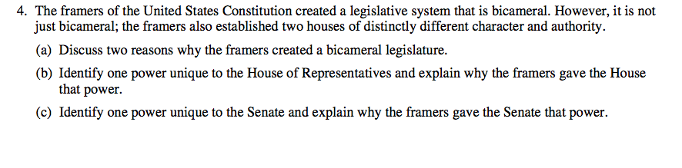2009
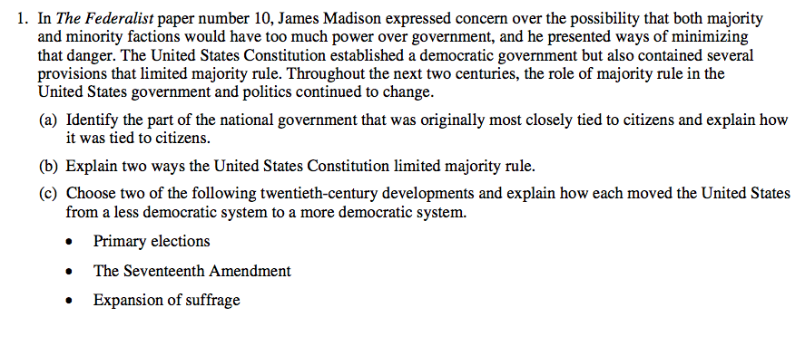
2011 (Don’t Worry about C)